**Expense Report Documentation**

**Project Overview**

This project provides a comprehensive analysis of expenses over six months. The primary objectives are to categorize expenses, identify spending patterns, and suggest ways to optimize spending. The analysis uses Pivot Tables and Charts in Excel to summarize and visualize data effectively.

**Data Overview**

The dataset includes the following categories:

- Entertainment

- Ticket and Bills

- Doctor and Medicine

- Food

- Grocery

- Miscellaneous

- Shopping

**Key Features and Analysis**

1. Monthly Expense Summary

A detailed breakdown of expenses for each month, highlighting the total spending and significant categories.

June Example

- Total Expense: ₹13,560

- Top Categories:

- Grocery: ₹4,690

- Shopping: ₹3,500

2. Category-wise Expense Analysis

Analyzes the total amount spent per category, providing insights into spending habits.

Category Breakdown

- Grocery: ₹30,990

- Entertainment: ₹12,000

- Shopping: ₹8,700

- Miscellaneous: ₹7,720

3. Item-wise Detailed Analysis

Detailed analysis for sub-items within categories, providing a granular view of spending.

Entertainment and Ticket & Bills Example

- Movie: ₹1,000

- Electricity Bill: ₹370

- Gas: ₹850

- Railway Monthly Ticket: ₹350

4. Frequency of Expenses

Counts the number of transactions for different items within each category, giving a sense of spending frequency.

Example

- Grocery: 15 times

- Food: 6 times

- Entertainment: 4 times

5. Highest and Second Highest Expenses

Identifies the categories with the highest expenses and provides a detailed breakdown.

Example

- Highest: Grocery - ₹27,400

- Second Highest: Shopping - ₹6,240

6. Visual Representations

Utilizes Pivot Charts and Conditional Formatting to visually represent the data, making it easier to identify trends and outliers.

Visualization Techniques

- Pivot Charts: For visual comparison of expenses across categories and time.

- Data Bars: For highlighting categories with the highest and lowest expenses.

7. Monthly Trends

Tracks the trend of expenses across different months, helping to identify patterns or seasonal variations in spending.

Example

- Peak Spending Month: February - ₹15,620

8. Recommendations

Provides actionable insights for optimizing expenses and increasing savings.

**Action Plan**

1. Set a Budget: Define monthly budgets for different categories and monitor spending.

2. Monitor and Adjust: Regularly review and adjust budgets based on spending patterns.

3. Increase Income: Explore additional income sources like freelance work or part-time jobs.

**Contributors**

- Sai Balaji Valluru

- Adde Rahul

- Kanukutla Alekhya

- Thimmapuram Surendar Goud

- Karthik

**Expense Summary**

**Total Expenses by Category**

* **Doctor and Medicine**: ₹450
* **Entertainment**: ₹1000
* **Food**: ₹850
* **Grocery**: ₹4690
* **Miscellaneous**: ₹500
* **Shopping**: ₹3500
* **Ticket and Bills**: ₹2570
* **Grand Total**: ₹13560

**Visual Representation (Pivot Chart)**

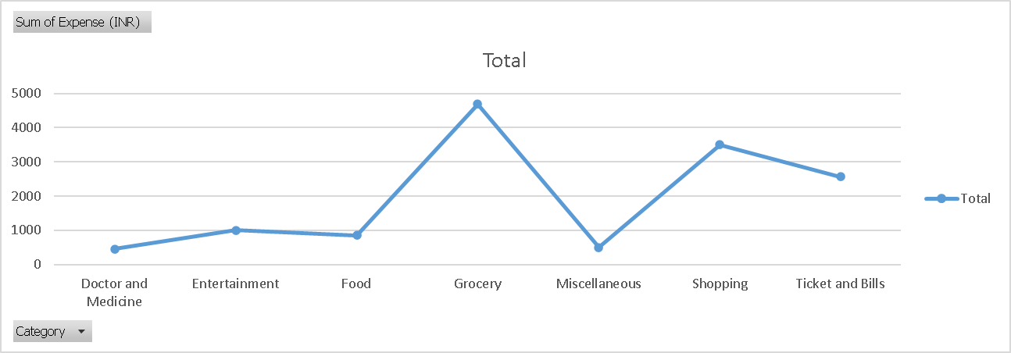

**Detailed Expenses**

**Entertainment and Tickets & Bills**

* **Entertainment**: ₹1000 (Movie)
* **Tickets & Bills**: ₹2570 (Electricity bill, Gas, House help, Railway monthly ticket)

**Visual Representation (Pivot Chart)**

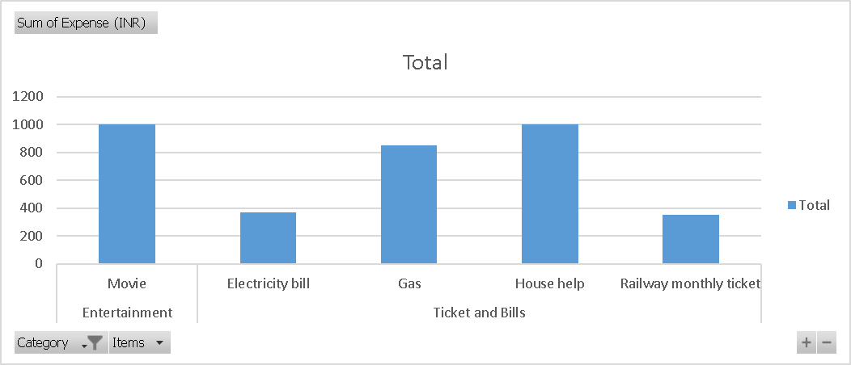

**Frequency of Expenses**

* **Beverages**: 1
* **Grocery**: 1 (Bread and bakery)
* **Chips and Fries**: 2
* **Food**: 2 (Online Food Order)
* **Electricity bill**: 1
* **Ticket and Bills**: 1 (Railway monthly ticket)
* … (and so on)

**Filtered Data for June**

**Grocery and Shopping Items**

* **Grocery**: ₹2740 (Foodgrains and cereals, Oil and spices, Vegetables, Fruit, Bread and bakery)
* **Shopping**: ₹3500 (Shoes)

**Visual Representation (Data Bars)**

|  |  |  |  |
| --- | --- | --- | --- |
| **Date** | **Category** | **Items** | **Expense (INR)** |
| 2-Jun | Grocery | Foodgrains and cereals | 1,050 |
| 2-Jun | Grocery | Oil and spices | 550 |
| 2-Jun | Entertainment | Movie | 250 |
| 3-Jun | Food | Online Food Order | 150 |
| 3-Jun | Doctor and Medicine | Mother's Medicine | 450 |
| 4-Jun | Ticket and Bills | Railway monthly ticket | 350 |
| 6-Jun | Grocery | Vegetables | 450 |
| 6-Jun | Grocery | Fruit | 150 |
| 8-Jun | Food | Chips and Fries | 100 |
| 9-Jun | Grocery | Bread and bakery | 100 |
| 10-Jun | Shopping | Shoes | 1000 |
| 11-Jun | Grocery | Vegetables | 250 |
| 12-Jun | Food | Online Food Order | 100 |
| 12-Jun | Entertainment | Movie | 250 |
| 13-Jun | Grocery | Beverages | 250 |
| 13-Jun | Ticket and Bills | House help | 1000 |
| 14-Jun | Ticket and Bills | Electricity bill | 370 |
| 15-Jun | Ticket and Bills | Gas | 850 |
| 15-Jun | Grocery | Fruit | 200 |
| 16-Jun | Grocery | Vegetables | 470 |
| 19-Jun | Miscellaneous | Sister's birthday gift | 500 |
| 19-Jun | Grocery | Bread and bakery | 200 |
| 20-Jun | Food | Chips and Fries | 150 |
| 22-Jun | Food | Online Food Order | 150 |
| 23-Jun | Entertainment | Movie | 250 |
| 24-Jun | Grocery | Vegetables | 250 |
| 25-Jun | Shopping | Tshirt and Jeans | 2500 |
| 26-Jun | Grocery | Fruit | 200 |
| 26-Jun | Grocery | Bread and bakery | 200 |
| 27-Jun | Entertainment | Movie | 250 |
| 28-Jun | Food | Online Food Order | 200 |
| 29-Jun | Grocery | Fruit | 100 |
| 29-Jun | Grocery | Vegetables | 270 |

**Month-wise Trend of Expenses**

|  |  |
| --- | --- |
| **Month** | **Total Expense (INR)** |
| January | ₹13900 |
| February | ₹15620 |
| March | ₹13140 |
| April | ₹14800 |
| May | ₹13370 |
| June | ₹13560 |
| Grand Total | ₹84390 |

**Highest Spending Month**

February: ₹15620

**Category-wise Expenses**

|  |  |
| --- | --- |
| **Category** | **Total Expense (INR)** |
| Grocery | ₹30990 |
| Ticket and Bills | ₹16040 |
| Entertainment | ₹12000 |
| Shopping | ₹8700 |
| Miscellaneous | ₹7720 |
| Food | ₹4940 |
| Doctor and Medicine | ₹4000 |
| Grand Total | ₹84390 |

**Visual Representation (Data Bars)**

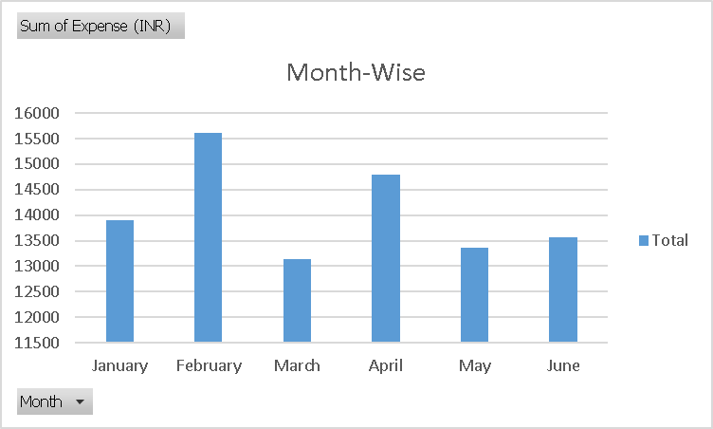

**Highest and Second Highest Expenses**

|  |  |
| --- | --- |
| **Category** | **Total Expense (INR)** |
| Grocery | ₹2740 |
| Vegetables | ₹1690 |
| Foodgrains and cereals | ₹1050 |
| Shopping | ₹3500 |
| Tshirt and Jeans | ₹2500 |
| Shoes | ₹1000 |
| Grand Total | ₹6240 |

**Highest Spending Items (Movies and Dining Out)**

* January: ₹1250
* March: ₹1300
* April: ₹1100
* May: ₹500
* June: ₹1000
* Grand Total: ₹5150

**Conclusion**

This documentation provides a comprehensive view of spending patterns and offers actionable recommendations for better financial management. By leveraging Excel’s analytical tools, the project delivers valuable insights into personal finance.